**Laporan Praktikum**

**Pemrograman Web**



**Nama : Renza Syamdia Naufal**

**Kelas : 1 D4 Teknik Informatika A**

**NRP : 3124600019**

**Praktikum – 2**

1. **Percobaan – Hello World**
   1. **Code**

<!DOCTYPE html>

<html>

<body>

    <h1> Coba PHP </h1>

    <?php

    echo "Hello World!";

    ?>

</body>

</html>

* 1. **Hasil**

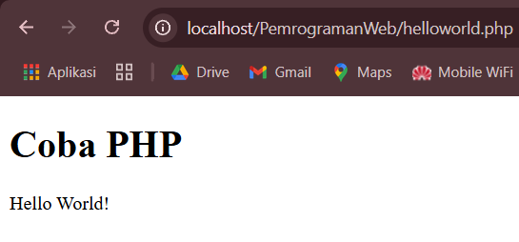

1. **Percobaan – PHP Variable**
   1. **Code**

<!DOCTYPE html>

<html>

<body>

    <?php

    $txt = "Mencetak Variabel!";

    $x = 5;

    $y = 10.5;

    echo $txt;

    echo "<br>";

    echo $x;

    echo "<br>";

    echo $y;

    ?>

</body>

</html>

<!DOCTYPE html>

<html>

<body>

    <?php

    $txt = "PHP";

    echo "saya sedang belajar " . $txt . "!";

    ?>

</body>

</html>

* 1. **Hasil**

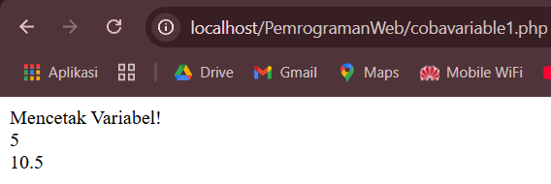

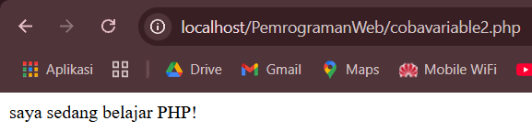

1. **Percobaan – PHP Display Output**
   1. **Code**

<!DOCTYPE html>

<html>

<body>

    <?php

    echo "<h2>Belajar PHP menyenangkan!</h2>";

    echo "Hello world!<br>";

    echo "Sedang belajar PHP!<br>";

    echo "Tes 1 ", "Tes 2 ", "Tes 3 ", "Tes 4 ", "Tes 5";

    ?>

</body>

</html>

<!DOCTYPE html>

<html>

<body>

    <?php

    print "<h2> Belajar PHP menyenangkan!</h2>";

    print "Hello world!<br>";

    print " Sedang belajar PHP!<br>";

    ?>

</body>

</html>

* 1. **Hasil**

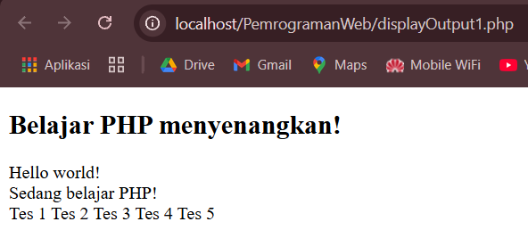

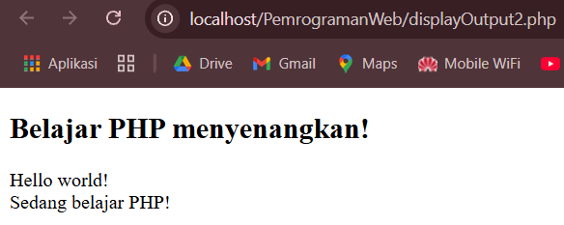

1. **Percobaan – PHP String**
   1. **Code**

<!DOCTYPE html>

<html>

<body>

    <?php

    echo str_word_count("Hello world!");

    ?>

</body>

</html>



<!DOCTYPE html>

<html>

<body>

    <?php

    echo strrev("Hello world!");

    ?>

</body>

</html>



<!DOCTYPE html>

<html>

<body>

    <?php

    echo str_replace("world", "Dolly", "Hello world!");

    ?>

</body>

</html>

* 1. **Hasil**

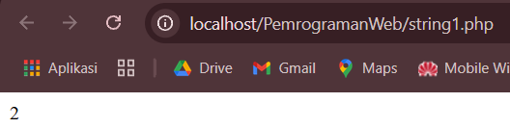



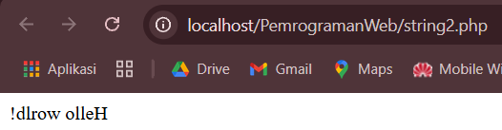



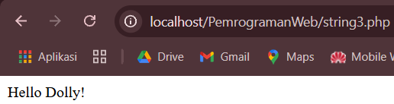

1. **Percobaan – PHP Operator**
   1. **Code**

<!DOCTYPE html>

<html>

<body>

    <?php

    $x = 10;

    echo $x;

    ?>

</body>

</html>



<!DOCTYPE html>

<html>

<body>

    <?php

    $x = 10;

    $y = 6;

    echo $x * $y;

    ?>

</body>

</html>



<!DOCTYPE html>

<html>

<body>

    <?php

    $x = 10;

    echo ++$x;

    ?>

</body>

</html>

* 1. **Code**

